Using Add-ons in events – including Golf Outings
Ver1: April 20, 2015

Please make sure you are familiar with creating events before reading this document.

About add-ons
Add-ons significantly extend what you can with an event.
As the name suggests you can use them to create additional registration options. For example, if you want your registrants to be able to rejoin the chapter at the same time as registering for an event.
In some cases you may even decide that you set the base registration price to $0, and then use the add-ons to provide every available option. This might be required for an event like a golf event where you are selling both dinner tickets and full golfer packages from the same registration link.

Adding options to events – for example Chapter Membership
The most basic use of the add-on is to provide an option to purchase an additional item at the time of registration – for example chapter membership.

The registrant would see a menu like the one below when they register.
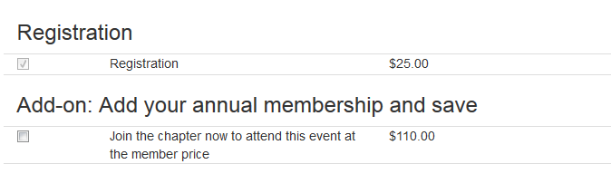

This is created using an add-on like the one shown below, while editing the event:
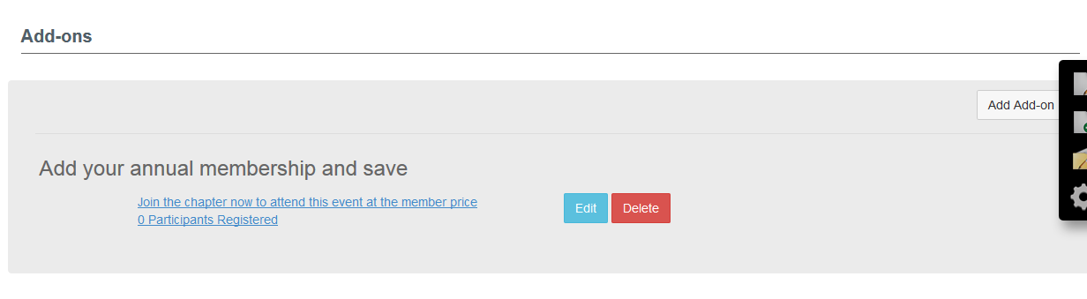

While creating the add-on, you can choose from a range of different add-on types
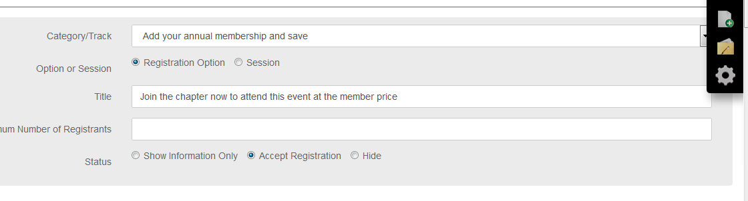

You can set the add-on to be a single price, but in this case the pricing is more complicated because it depends whether the person is a CFA member or not.
NOTE: When you are selling a chapter membership as an add-on, you MUST include the chapter member price categories with a zero price. This will prevent existing members from buying a new membership.
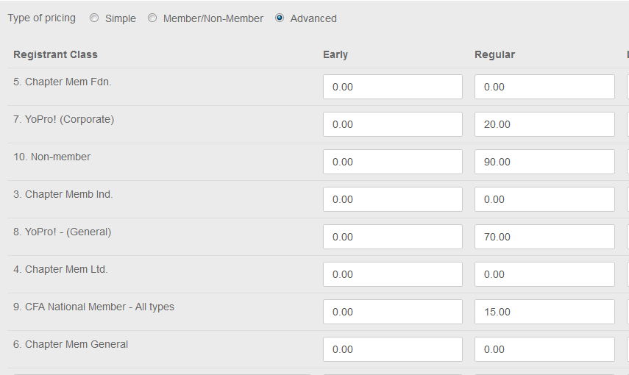

Using add-ons where no registration is required
Sometimes you may want to just sell a sponsorship without requiring an event registration.
You can do this using the event module by having a zero registration fee, and using an add-on.
For example – here is the add-on setup for a chapter sponsorship, both as the purchaser sees it and in the setup.
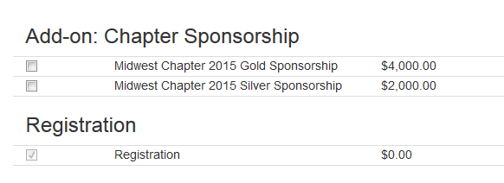

NOTE: The event is set up so that the sponsorship shows above the registration box. This is achieved by choosing the correct add-on category. Some show above the registration line, some below. A table is provided at the end of this document.

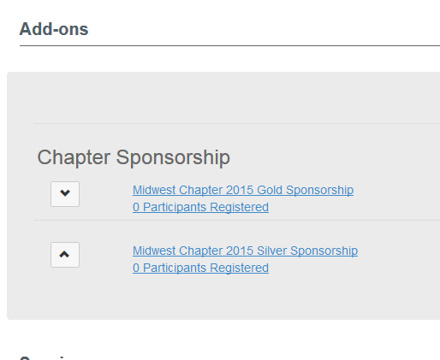

Using add-ons to provide alternative price options
The event manager is set-up to choose the correct price for each attendee. But sometimes you might want to simply let the attendee choose between a couple of different options. For example, you might want to offer a different price to TMA members, and are happy to rely on your registrant’s honest.

In this case you would set up the pricing using the category called “Please choose the appropriate registration price”, and set up your two prices
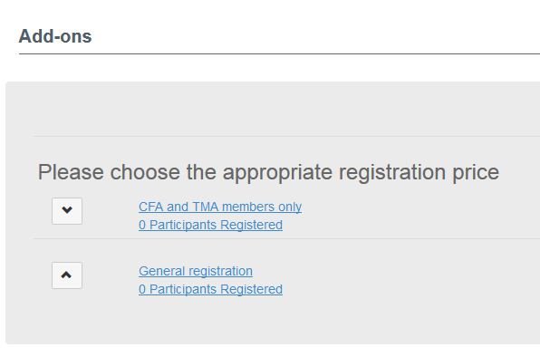

The registrants would see this as shown below
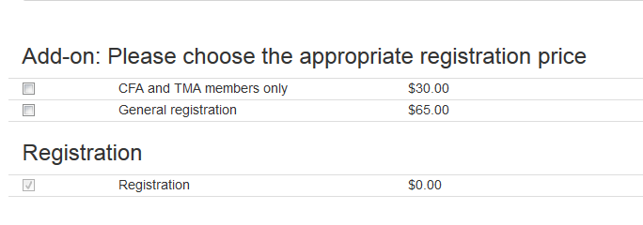

Setting up a Golf Event
Let’s start with the end-goal in mind, which is to create a menu of options for the attendee at registration. See the example below. Note that the way this event is setup, registration is already checked, and registration cannot proceed unless the registrant chooses at least one other option. Additional rules are set up so that you can’t choose options which are incompatible, such as a “dinner only” plus “golfer” for the same registrant.
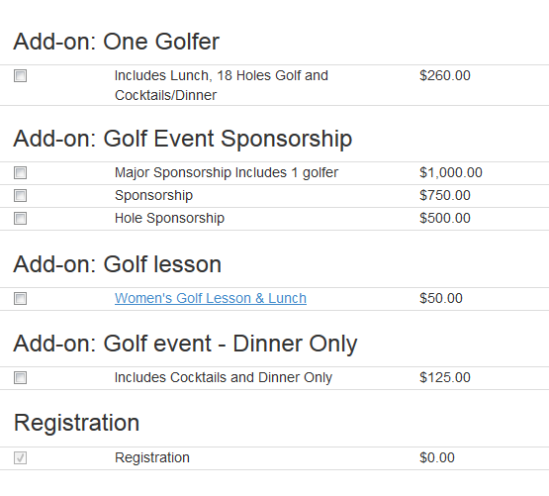

The structure of the event setup is fairly straightforward. You simply create a new add-on for each additional item you see in the list above
The initial event set up is exactly as you would for any other event. The event type is “Chapter Meeting” as always.
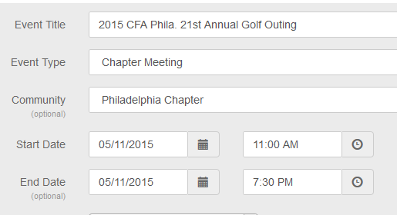

Just set the event price to be zero for all registrants
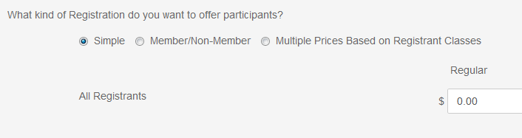

Then you create a series of add-ons for the type of options you want to make available:


This particular event uses 6 different add-ons, and you need to create each separately.
When you create the add-on, make sure you choose the correct category because these categories will be the headings for the menu that the registrants sees when they register.
For example, for dinner-only, select the dinner-only type. These are always “registration options” since the “session” option does not permit pricing.
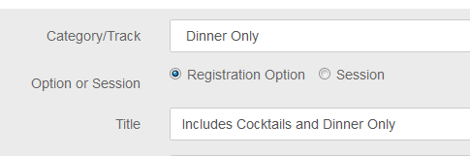
You can set you your pricing using the options you would for usual registration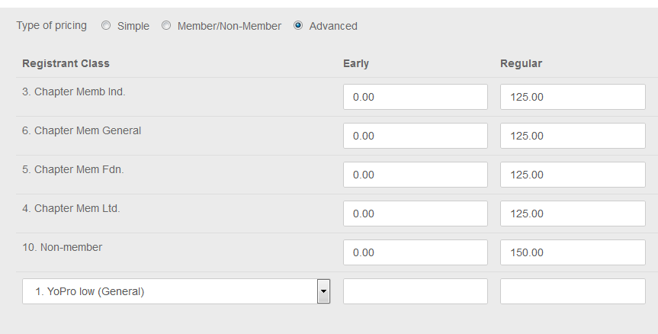

Remember to use the “Advanced” option so you can correctly distinguish between chapter members and corporate members.
You can add more detailed descriptions for any add-on if you wish.

Once you have set up all the options you can also create some rules, and these are found at the bottom of the add-on screen.
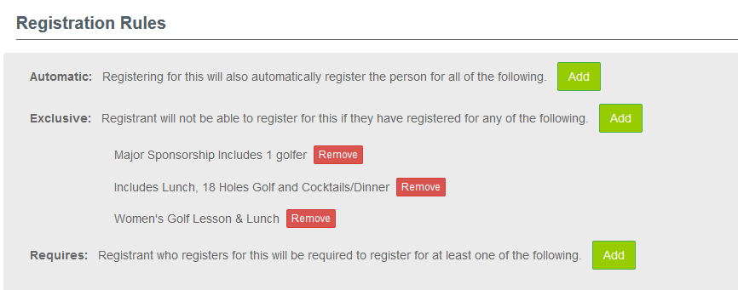
The rules aren’t essential, because most people won’t buy incompatible options anyway, but just incase you can create rules that prevent the registrant buying two incompatible add-ins. In this case these are the rules for the “dinner only” option.
They can’t choose dinner only if they have registered as a golfer – because golf includes dinner.
They can’t choose the major sponsorship and dinner, because the major sponsorship includes dinner
In this case the set-up also prohibits someone from buying the golf lesson together with dinner only, but that is a choice made by the chapter.

Checking that your golf event will work
Usually once you have completely set up a golf event, you would want to test it, especially with all these options. It looks complex. But in this case testing is very simple.
Simply try to register yourself, and you will see the menu of options again.
Just try selecting some of the checkboxes in a way that would not make sense.
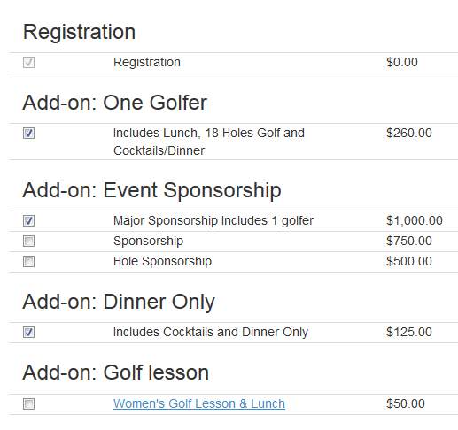
If the rules are correct, you will see an error message which tells you what is wrong. In this case it detected two incompatible selections
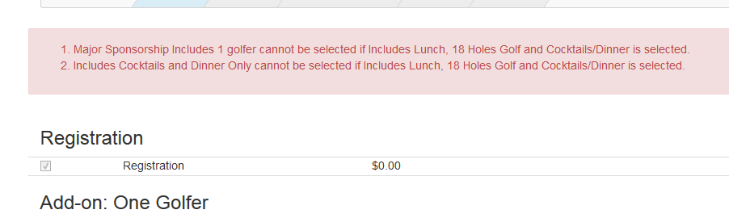

You can also check to make sure that there are no errors when all of the acceptable combinations are chosen. You may still be concerned about whether the member will see member pricing and the non-member see non-member pricing. For that you would need to create an “alter-ego” for yourself that is not a chapter member.

